Progress report- Phase 3: Data Preparation & Phase 4: Baseline Model Development

1. Phase 3 – Data Preparation

1.1 Input Data
The following files generated in the previous phases were used:
- smiles_labels_valid.csv – dataset containing SMILES strings and activity labels
- X_ecfp2048.npy – Morgan fingerprint features (ECFP, 2048 bits)
- y.npy – binary activity labels (active / inactive)
The Morgan fingerprints represent the structural environment of atoms in the molecules and serve as the feature matrix for the machine learning model.

2. Scaffold Generation and Data Splitting
To simulate realistic drug discovery conditions, a scaffold-based split was implemented instead of a random split.

Process
1. SMILES strings were converted to RDKit molecular objects.
2. Bemis–Murcko scaffolds were generated for each molecule.
3. Molecules were grouped based on scaffold.
4. The dataset was split into:
- Training set: 80%
- Test set: 20%
This ensures that the model learns from one set of scaffolds and is evaluated on different scaffolds.

3. Handling Class Imbalance
The dataset contains a strong class imbalance, with only ~5% of compounds labeled as active.
To address this, two strategies were tested:
1. Class weighting in XGBoost
2. SMOTE (Synthetic Minority Over-sampling Technique)
Model performance was evaluated using AUPRC (Area Under the Precision–Recall Curve).

4. Phase 4 – Baseline Model (XGBoost)

4.1 Model Selection
XGBoost was selected as the baseline model because it:
- Performs well on tabular datasets
- Handles class imbalance effectively
- Trains quickly
- Provides feature importance for interpretability

5. Baseline Model Training
A baseline XGBoost classifier with class weighting was trained. The class imbalance was handled using the parameter scale_pos_weight which increases the penalty for misclassifying the minority class.

6. Baseline Model Evaluation
Performance Metrics:
AUPRC = 0.36317838849424927
ROC-AUC = 0.7925
Precision–Recall Curve (Baseline):
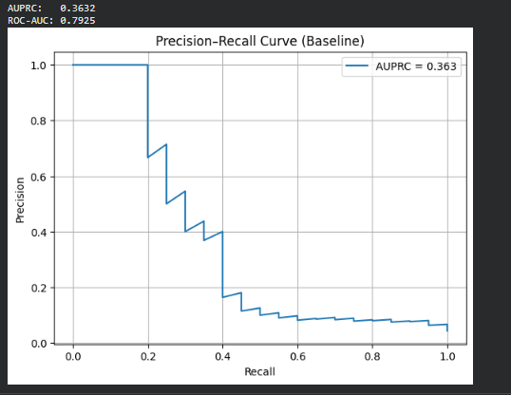

7. SMOTE Experiment
To further address class imbalance, SMOTE was applied to the training data.
Training data change:
Before SMOTE: 100 positives / 1868 samples
After SMOTE: 1768 positives / 3536 samples

8. SMOTE Model Evaluation
Performance Metrics:
AUPRC = 0.27717748918142826
ROC-AUC = 0.8155829596412557
Precision–Recall Curve (SMOTE):
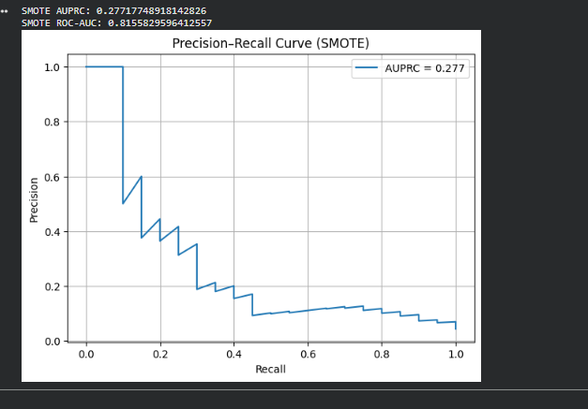

9. Comparison of Models
Baseline XGBoost: AUPRC = 0.3632 | ROC-AUC = 0.7925
SMOTE + XGBoost: AUPRC = 0.2772 | ROC-AUC = 0.8156

10. Conclusion
The baseline class-weighted XGBoost model outperformed the SMOTE-based model in terms of AUPRC, which is the most relevant metric for this imbalanced classification problem.
Although SMOTE slightly improved ROC-AUC, it reduced AUPRC, suggesting that synthetic samples introduced patterns that were not beneficial for identifying true active compounds.
Therefore, the baseline model will be retained for further development and optimization.

